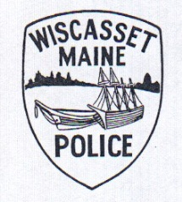
WISCASSET POLICE DEPARTMENT
51 Bath Road, Wiscasset, ME 04578
PHONE: (207) 882-8202 FAX: (207) 882-8203
EMAIL: patrol@wiscassetpd.org

Troy A. Cline Alfred W. Simmons
Chief of Police Sergeant

Wiscasset Police Department – Full Time Patrol Officer
The Town of Wiscasset has an immediate opening for a highly motivated; community oriented full time Patrol Officer. Qualified candidates must hold a valid Maine driver’s license at the time of employment. An Associates Degree in Criminal Justice or related field, or a combination of relevant training and experience is desirable. Preference is given to graduates of the Maine Criminal Justice Academy basic school with School Resource Officer (SRO) experience / training.
The minimum requirement is successful completion of the Maine Law Enforcement Pre-Service school. Candidates must be at least 21 years of age, have no criminal or adverse traffic record and will be required to pass a polygraph, medical, psychological tests and an extensive background check.
The Town of Wiscasset has a year round population of 4,000 and is the “gateway” to midcoast Maine. The Wiscasset Police Department provides 24 hour coverage, 7 days a week and is actively engaged in the community. We are a small, energetic, community oriented police department focused on professionalism and “esprit de corps”.
Interested candidates should submit an application for employment, cover letter, resume and five (5) references. Applications are available at the Wiscasset Police Department, 51 Bath Road, Wiscasset, Maine 04578 during normal business hours or on our website www.wiscassetpd.org. Review of resumes will start on April 8th, 2016.
The Town of Wiscasset is an Equal Opportunity Employer. EEO

