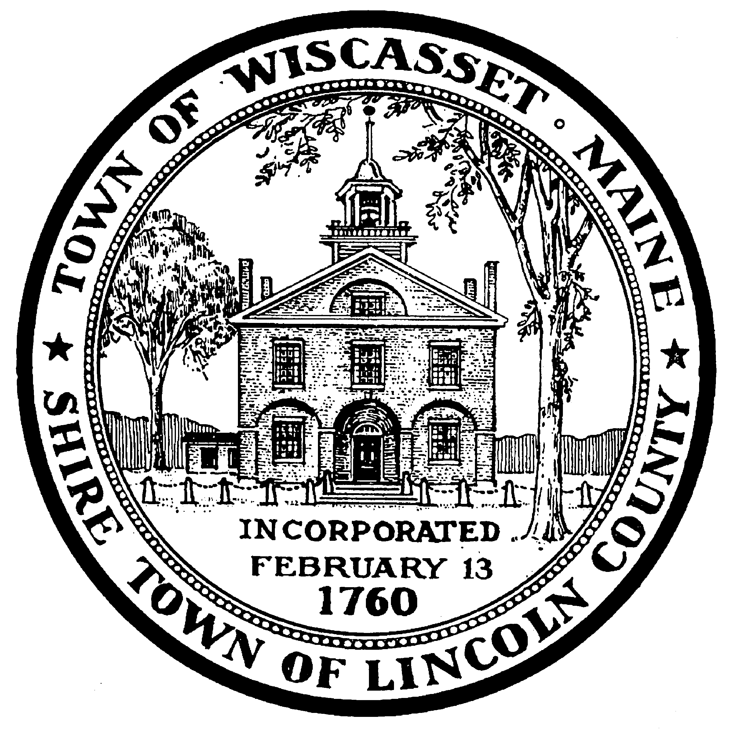
+-
Office of
Planning & Codes
-

PUBLIC HEARING NOTICE
Liquor License Renewal
Wiscasset Board of Selectmen
March 3, 2009 @ 7:00 p.m. in Municipal Building Hearing Room

1. APPLICANT: Sarah Heald
BUSINESS NAME: Sarah’s Café and Twin Schooner Pub
LOCATION: 45 Water Street, Wiscasset, ME

